This test contains questions from some of the previous four topics you’ve covered.

**1**

**a)** Which of the following reactions was exothermic and which were endothermic? (3)

|  |  |  |  |  |
| --- | --- | --- | --- | --- |
| **Reaction** | | **Start temperature °C** | **Final temperature °C** | **Exothermic or endothermic** |
| A | Magnesium + hydrochloric acid | 21 | 35 |  |
| B | Citric acid + sodium hydrogencarbonate | 25 | 19 |  |
| C | Sodium hydroxide + sulfuric acid | 25 | 27 |  |

The results for the reactions shown above were found by experiments using the equipment shown below.

**b)** Why is the reaction done in an insulated vessel with a lid? (1)



**c)** How would you carry out this experiment for the sodium hydroxide and sulfuric acid reaction? You should include details of measurements you would take, describe test details (so you can compare results with the other reactions) and safety procedures. (6)

**d)** Sketch the energy profile for the reaction of magnesium and hydrochloric acid on the graph below. (2)



**e)** Which of the three reactions would be best for use in a sports injury pack? (1)

**2**

**a)** What is the activation energy of a reaction? (2)

**b)** On the graph below, draw the energy diagram for an endothermic reaction. Label the activation energy and, on the same diagram, show the energy profile of a catalysed reaction. (5)

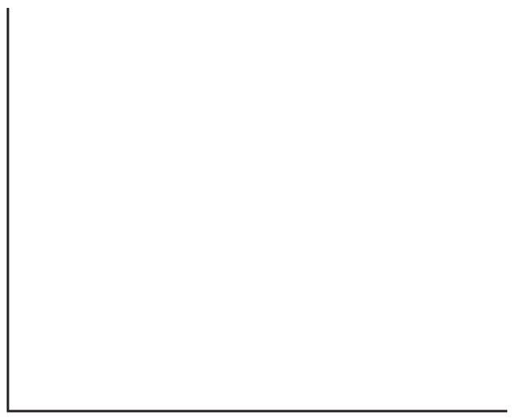

**3** Energy can be obtained from fuel cells such as the hydrogen oxygen fuel cell.

hydrogen + oxygen → water

2H2 + O2 → 2H2O

The bond energies are given below:

|  |  |
| --- | --- |
| Bond | Energy / kJ |
| H–H | 436 |
| O=O | 496 |
| O–H | 463 |

**a)** Calculate the overall energy change for this reaction and state if it is exothermic or endothermic. (4)

**b)** State one advantage of the hydrogen oxygen fuel cell over a petrol engine. (1)

**4** Below are two models that were developed to explain the structure of the atom.

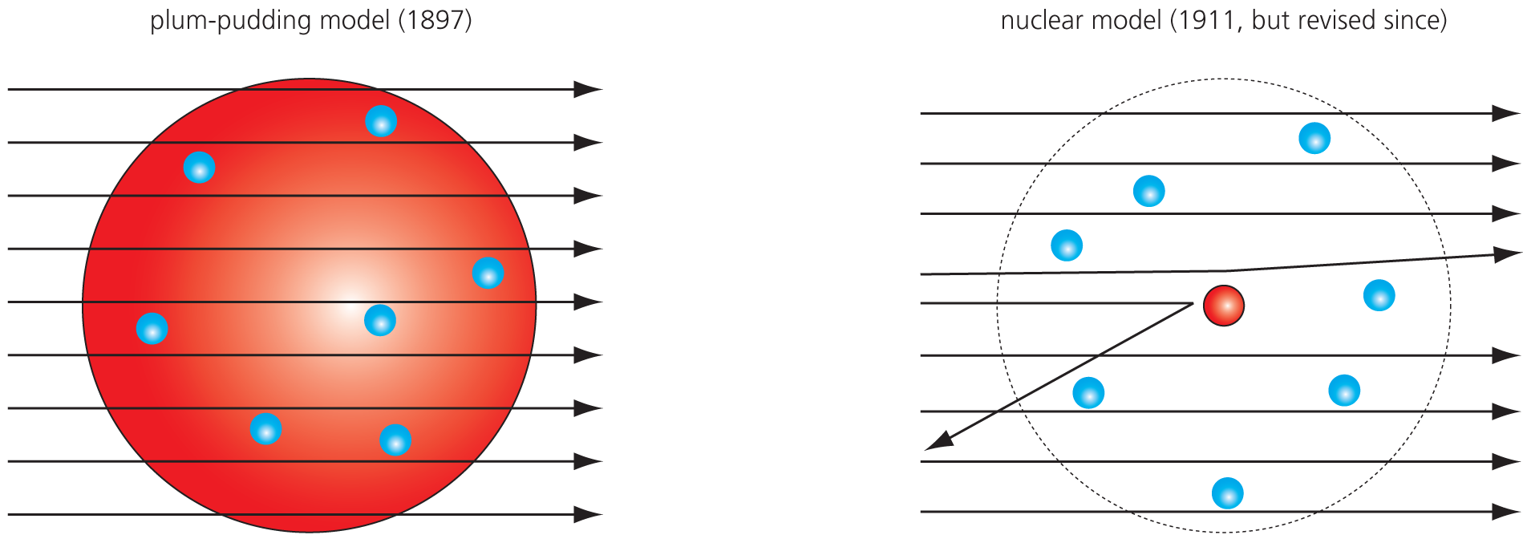

**a)** What does the nuclear model on the right show about the structure of the atom? (1)

**b)** Now we know more about the structure of the atom. Name the three particles that make up atoms, give their mass, their charge and say where they are in the atom. (4)

**5** The periodic table contains all the elements we know.

**a)** What is an element? (2)

**b)** We represent the element aluminium like this:

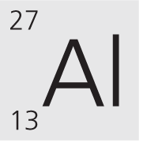

**i)** What does the top number represent? (1)

**ii)** What does the bottom number represent? (1)

**iii)** Aluminium is in Group 3 of the periodic table. Give its electronic configuration. (2)

**6** Below is a table showing the properties of various substances:

|  |  |  |  |  |
| --- | --- | --- | --- | --- |
| **Substance** | **Melting point / °C** | **Conduct electricity when solid?** | **Soluble in water?** | **Conduct electricity when in water?** |
| A | 801 | No | Yes | Yes |
| B | −183 | No | No | – |
| C | 1535 | Yes | No | – |
| D | 963 | No | Yes | Yes |

**a)** Which of the above have giant structures? (2)

**b)** Which of the above could be salts? (2)

**c)** Which one of the above is a metal? (1)

**d)** What is the difference between a covalent bond and an ionic bond? (2)

**e)** Diamond and graphite are two forms of carbon. Graphite conducts electricity but diamond does not. Why? (1)

**7** Relative atomic masses: H = 1; O = 16; Ca = 40; Cl = 35.5; Mg = 24

**a)** What is the relative formula mass of each of the following:

**i)** H2O ____________ (1)

**ii)** CaCl2 ___________ (1)

**b)** 24 g of magnesium burns in 32 g of oxygen.

2Mg + O2 → 2MgO

**i)** What mass of magnesium oxide was formed? (1)

**ii)** How many moles of oxygen are needed for each mole of magnesium? (1)

**c)** Complete the two word equations below:

**i)** Hydrochloric acid + potassium hydroxide → _______________ + water (1)

**ii)** Magnesium + sulfuric acid → magnesium sulfate + _____________ (1)

Total = 50

**Answers**

**1**

**a)** A = exothermic; B = endothermic; C = exothermic (3)

**b)** To prevent/help stop heat loss. (1)

**c)**

|  |  |
| --- | --- |
| **Marks** |  |
| 6-5 | At least three different points well expressed |
| 4-3 | A couple of points mentioned |
| 2-1 | Not much detail |

* Measure out known volume of sodium hydroxide (measuring cylinder is OK).
* Place into polystyrene cup.
* Record temperature.
* Measure out known volume of sulfuric acid (measuring cylinder is OK).
* Wait until maximum temperature reached.
* Record final temperature.
* Fair test: same measured volumes for all chemicals, same thermometer, same container, repeat etc.
* Safety: safety glasses (need to mention why) because handling acids and alkalis, lab coat to prevent spills onto clothing.

**d)** Line drawn (1) **below** and to the right of the original line (1).

**e)** Reaction B (1)

**2**

**a)** The **minimum** amount of **energy** that particles must have to react. (2)

**b)** Line going up (1) then down (1) to end above original line (1). Activation energy labelled from the original line to the top of the peak (1). Second line which has a peak below the first one (1).

**3**

**a)** Energy in (break bonds = endothermic) = (436 × 2 ) + 496 = 1368 kJ (1)

Energy out (make bonds = exothermic) = (463 × 4) = 1744 kJ (1)

Difference = 376kJ (1) given out therefore exothermic (1).

**b)** Water only product therefore not polluting/not using up fossil fuels. (1)

**4**

**a)** The model shows that there is a **very small nucleus** surrounded by electrons. (1)

**b)** Proton, mass = 1, charge = +1, in nucleus

Neutron, mass = 1, charge = 0, in nucleus

Electron, mass ~ 1/2000, charge = −1, in shells

(All correct = 4; 1 or 2 errors = 3; 3 or 4 errors = 2; 5 or 6 errors = 1.)

**5**

**a)** An element is a **substance** made from **only one type of atom**. (2)

**b)**

**i)** Mass number (1)

**ii)** Atomic (proton) number (1)

**iii)** 2,8,3 (2)

**6**

**a)** A, C and D (all needed for 2 marks, 1 missed = 1 mark)

**b)** A and D (2)

**c)** C (1)

**d)** **Covalent share** electrons, **ionic transfer** electrons. (2)

**e)** Graphite has free/delocalised electrons. (1)

**7**

**a)**

**i)** 18  g (1)

**ii)** 111 g (1)

**b)**

**i)** 56 g (1)

**ii)** 0.5 moles (1)

**c)**

**i)** Potassium chloride (1)

**ii)** Hydrogen (1)

Total = 50